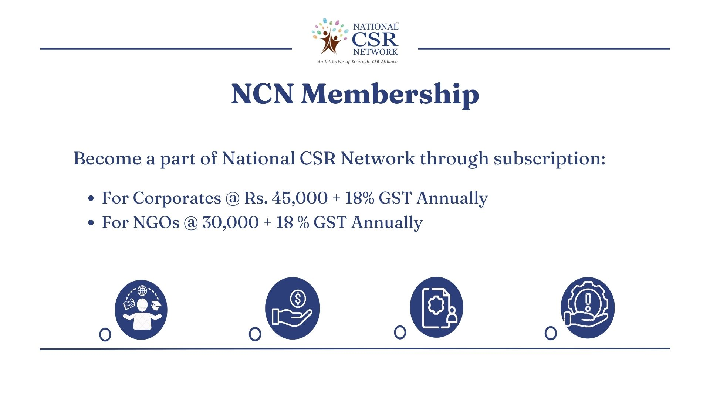

MEMBERSHIP FORM

(Please fill in block letters)

1. Name of the Organization:
2. Year established:
3. Name and Designation of Chief Executive:
4. Name and designation of principal representative for interface with NCN:
5. Phone: Mobile:
6. Email:
7. Website:
8. Address:
9. Area of interest (under CSR):
10. Payment (Details): Membership fee of Rs.

Cheque/DD No.: Dated:

Amount: Bank:

Please send the duly filled application form to:

Ms. Ritu Singh

National CSR Network

Contact No.: 7042350657

Correspondence Address: B-92 South City 1, Gurugram, Haryana

Email at: [ritu.singh@nationalcsrnetwork.in](mailto:ritu.singh@nationalcsrnetwork.in)